Report
The goal of this project is to classify different cough sounds to predefined categories. All audio files were sampled at 16000 Hz but as a precautionary measure, all the audios were resampled to 16Hz to ensure consistent temporal resolution across the recordings as varying sample rates could distort feature extraction. The sampling rate was chosen based on the sample frequency of the collected audio and according to Jocelin et. Al Citation link, respiratory sounds exhibit dominant cough frequencies below 4Hz but in order to capture more diverse patterns such as airflow patterns critical for different respiratory diseases 16Hz was chosen.
All the target labels were then standardized to lowercase ensuring consistent representation across the dataset. This was done to prevent introduction of artificial class imbalance and duplicated definitions arising from label inconsistencies.
A silence ratio was then computed for each recording enabling the assessment of the audio quality. The silence ratio was defined as the proportion of samples with amplitude below 0.01. The average silence ratio across the classes is as shown below.
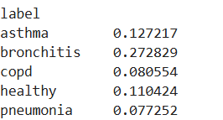
Audio duration was then assessed by taking the sample count averaged with the sample rate showing that most of the audio files are 6s long with an average of 5.91. The minimum audio length was 0.48 which were 2 samples from Asthma. To ensure consistent input dimensions, all audio files were padded to a minimum of 1.5s using zero padding. Zero padding was chosen as the number of files were smaller and thus the assumption was it would preserve the diagnostic information without distorting the signals.
Mel-Frequency Cepstral Coefficients (MFCCs) were then extracted from each padded waveform. MFCCs inform on how energy is distributed across frequencies capturing spectral shape, tonal characteristics among others. An MFCC coefficient of 13 was chosen as they capture essential spectral information while keeping models simple. Higher coefficients represent finer spectral details which are mostly redundant and not ideal for sound distinction.

Root mean squared and ZCR were then computed as complimentary features to capture both the intensity of the cough and how the waveform changes over time. These features capture complimentary aspects of cough characteristics such as amplitude dynamics and timbral characteristics providing a clear representation of different respiratory features necessary for distinction of the cough sounds. The average of MFCC, ZCR and RMS were then used for some of the Random Forest classifiers and the SVM.

CRNN
For CRNN, preprocessing involved waveform flattening which was due to error due to inconsistent dimension when the files were converted to tensors. This ensured that all the audio files have consistent dimensions. Mel spectrogram was used instead of average of the features. This is because CNN captures hierarchical feature representation from high dimensional inputs as opposed to the case of SVM and Random Forest which require compact feature representation which can lead to loss of spatial information. The second reason is because RNN (LSTM) requires the temporal sequence and taking average over the features distorts this sequence necessary for understanding cough dynamics. To ensure computational stability during modeling, the raw mel spectrogram are compressed to logarithmic range by converting to decibel scale which is then normalized to ensure unit variance and zero mean enabling the model to focus on relative spectral patterns rather than power levels which could affect the recording based on the environment.
The disease labels were then encoded using label encoder and the dataset split to 70% training and 15% test and validation using stratified splitting to account for the class imbalance ensuring each split maintains the original class distribution. The feature vectors were then wrapped with Dataset and DataLoader converting them to iterators necessary for and batchwise training where a batch size of 32 was used.
The train data loader is used to train a CRNN with two convolution blocks with filter of size 3 and ReLU activation followed by an LSTM layer and a final fully connected layer for the classification head mapping the hidden layer outputs to the class labels.

Modelling
Three models were trained with multiple experiments on each architecture.
- Random Forest Classifier default
The dataset was split into 80% training and 20% test with no stratification and the random forest classifier trained using default parameters with a 42 as the random state and 100 estimators. No engineered features were used for this model. The results are as shown below.
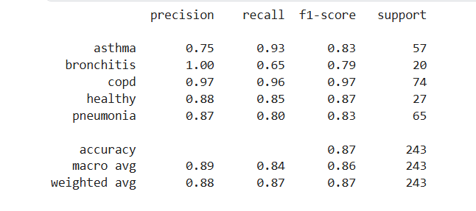
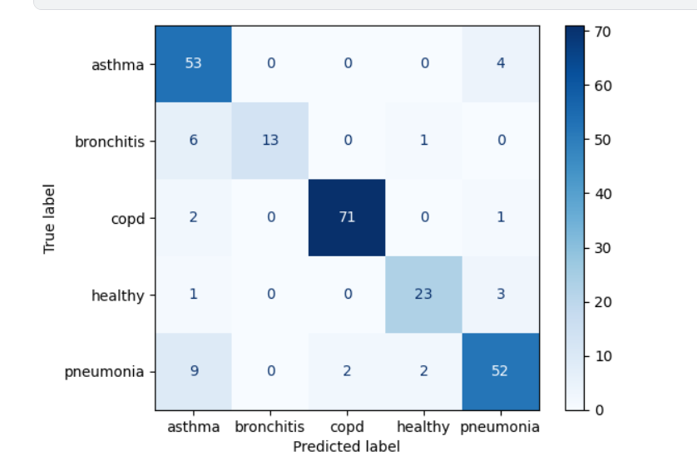

- Random Forest classifier with stratification and balanced class
The dataset was split into 80% training, 20% testing with stratification over the target to ensure representativeness in the splits. The feature vector was composed of average and standard deviation of MFCC, ZCR and RMS. The classifier was then initialized with a weighted class balance. The results are as shown below.
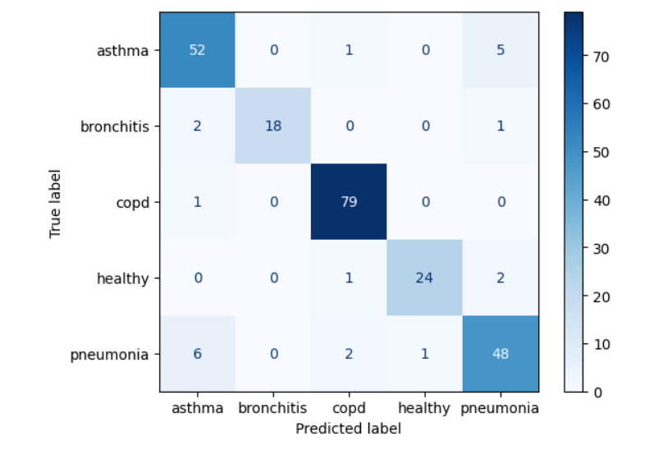
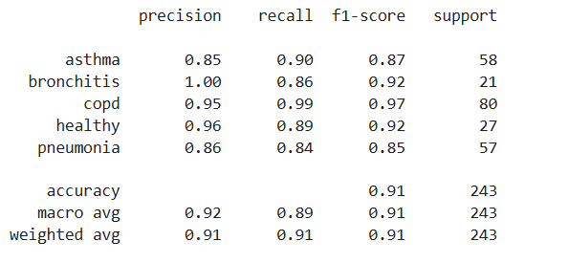
- SVM default
The data split was similar to the default random forest classifier. The classifier was initialized with default parameters but with balanced class weight and the results are as shown below.
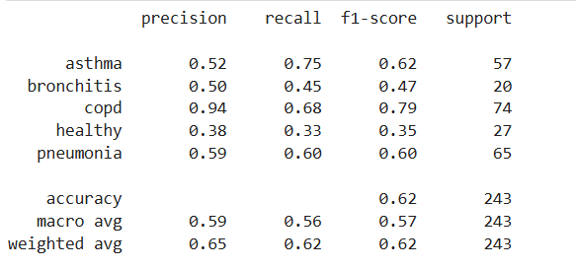
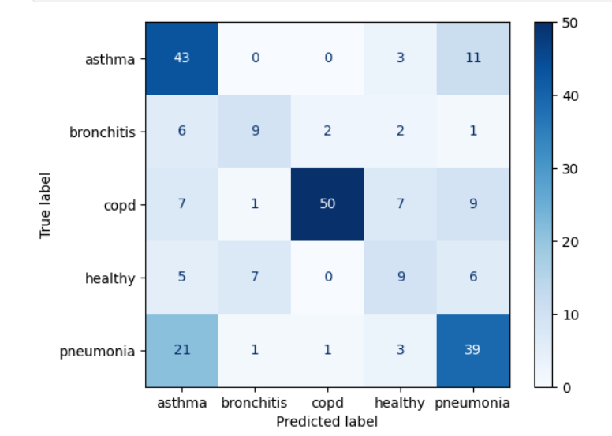
- SVM with scaling and stratification
The dataset was split into 80% training, 20% testing with stratification over the target labels. The dataset was then standardized to a unit variance and zero means using standard scale ensuring equal feature contribution. The results are as shown below.
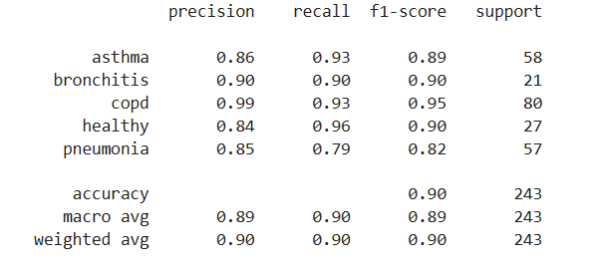
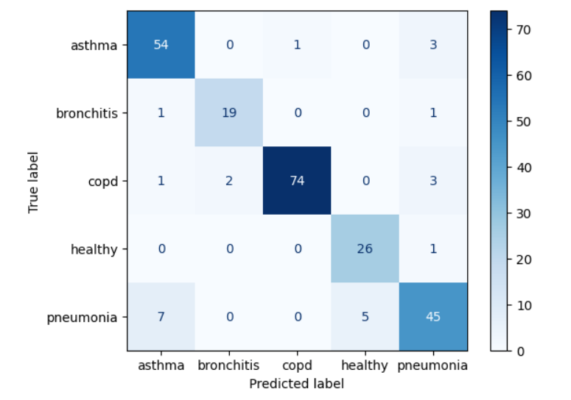
- CRNN: 20 epochs no early stopping or dropout
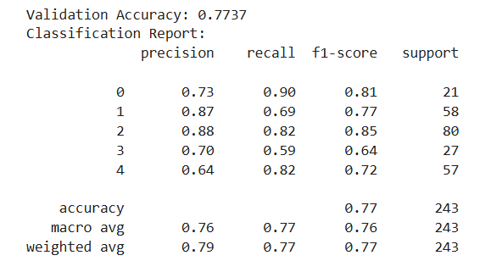

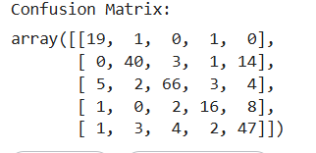
- CRNN: 20 epochs, Early stopping, no dropout

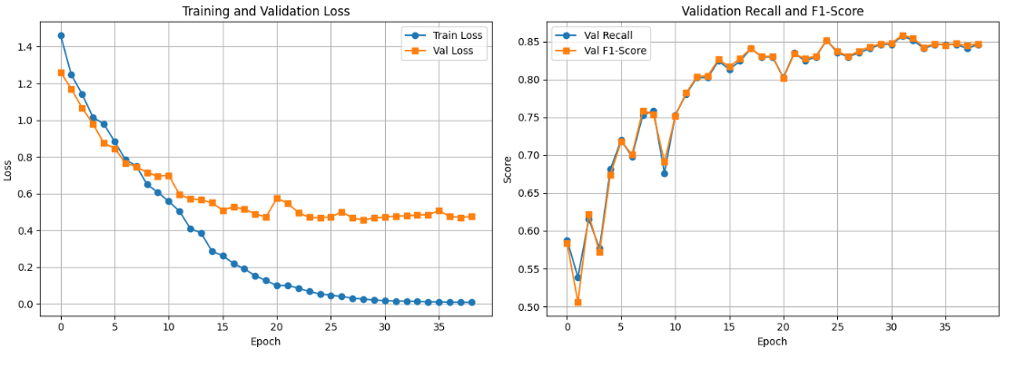
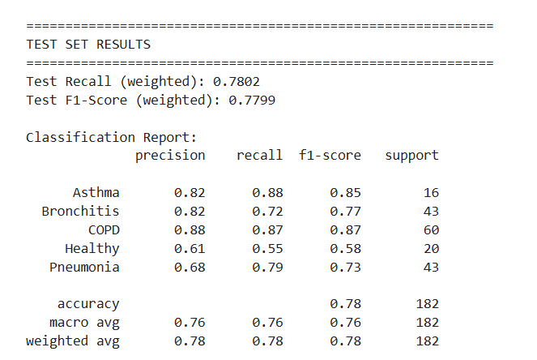
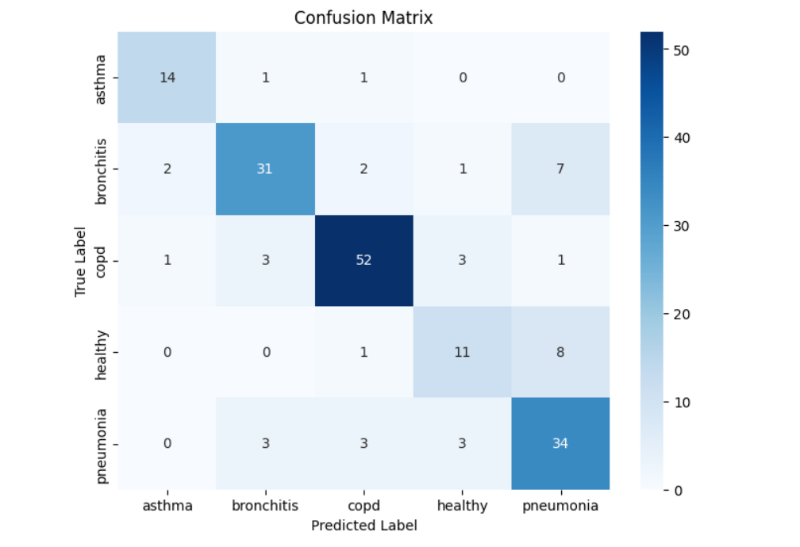
- CRNN: 50 epochs: Early stopping with 30% dropout
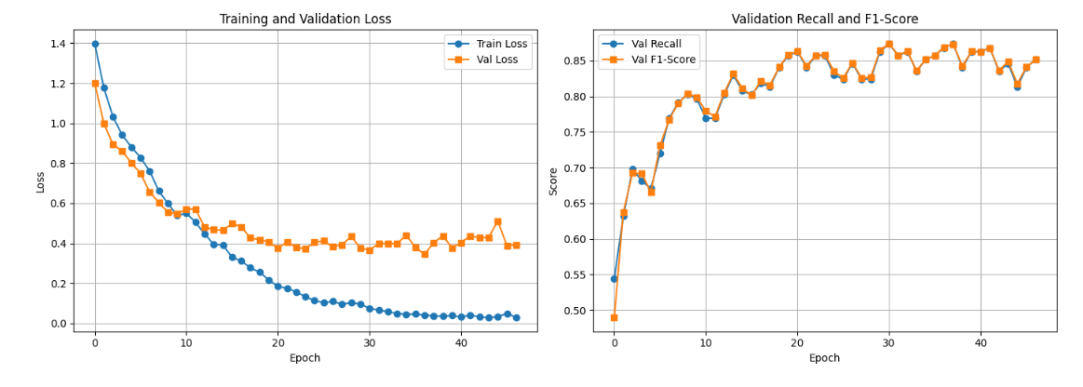
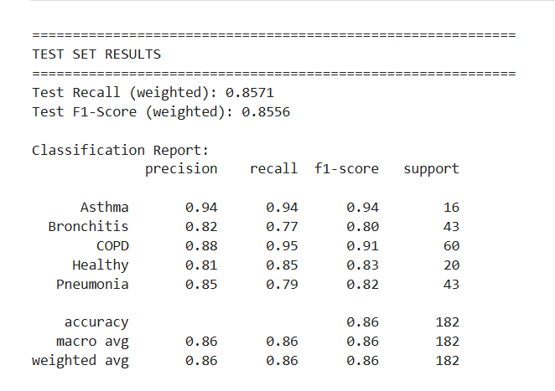
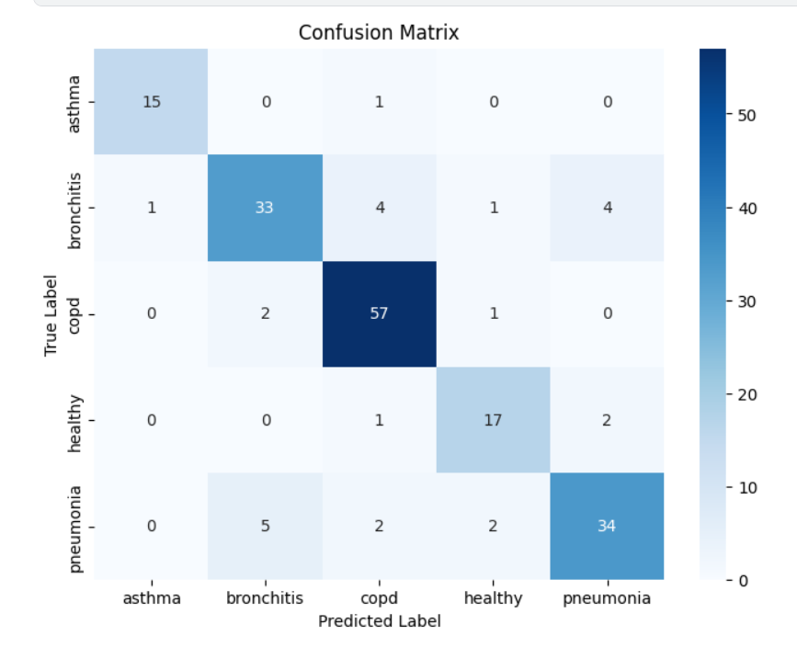

SpecAugmentation
Process of modifying spectrogram: visual representation of audio signal to improve performance of ML models.
It applies augmentation directly to the spectrogram including three main steps
- Time Warping: Shifts spectrogram left or right simulating variation in speech timing (stretch or compress parts of spectrogram)
- Frequency masking: Randomly masks out blocks of consecutive frequency channels helping the model become robust to partial loss of frequency information.
- Time Masking: Similar to frequency masking, but it blocks out ranges of time steps which can help the model learn to handle missing segments of audio.
Different clinics have different audio devices and also different patient characteristics, using the data as it risks the model memorizing the exact training patterns instead of learning generalizable signatures which can cause poor performance when exposed to new environments.
Without SpecAugmentation the model will be like, if I see frequencies of 100-150Hz at time 0-3s then it is pneumonia for example. But with SpecAugmentation, the model should be able to handle incomplete spectrogram cases e.g., due to noise bands on spectrogram

Spec Augmentation performance
No normalized names
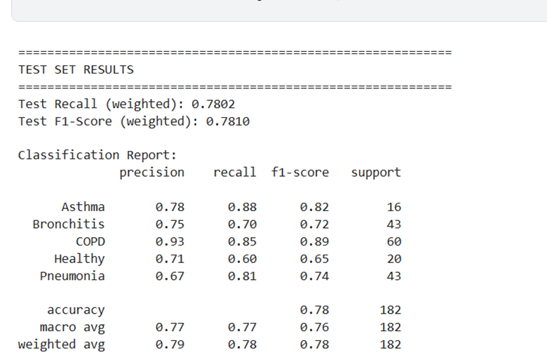
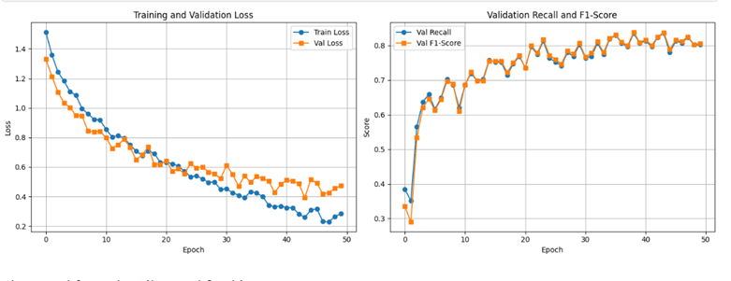
Total Training Time: 309.64 seconds
Spec Aug with normalized labels
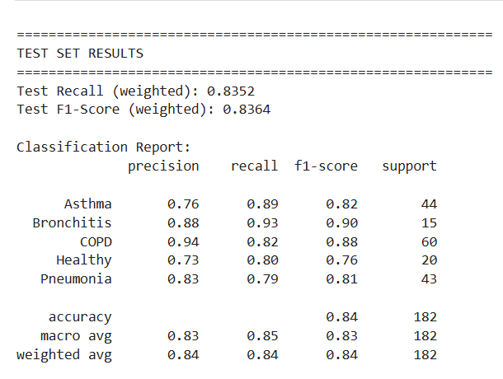
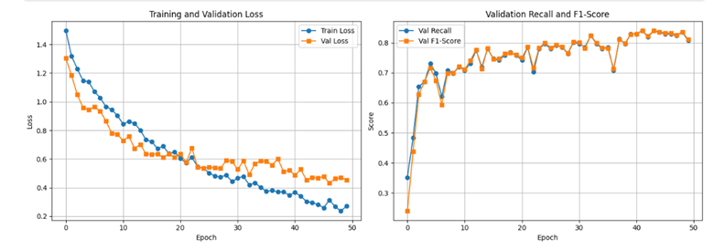
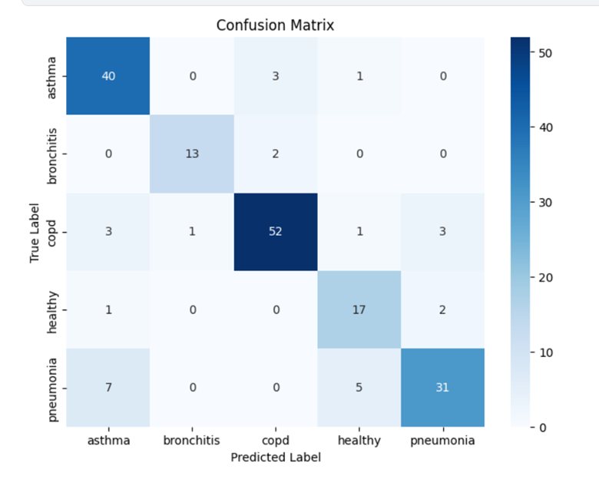
Total Training Time: 291.83 seconds

BP-SMOTE Link to publication
Considered but requires flattening of features in order to oversample which is what we are trying to avoid thus did not experiment on to see if performance will improve across.
Used normal smote with SVM and Random Forest together with audio augmentation and the performance worsened.
SVM performance with smote and augmentation
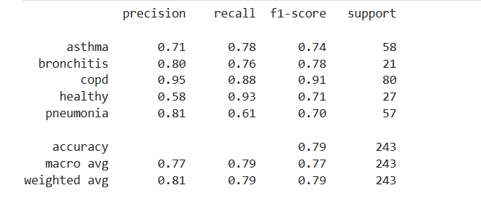
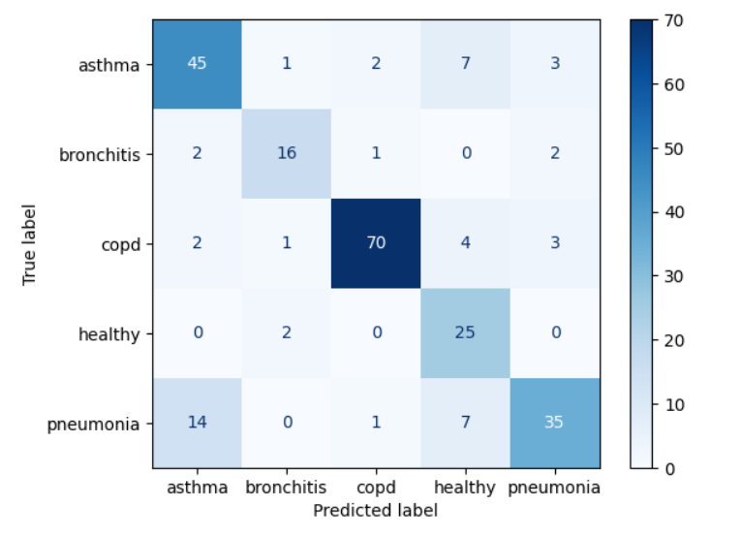
RF with smote and augmentation
